**Schema - Job Request Creation Domain**

**Domain**

All pieces that have to do with users that post and modify jobs for interpreters.

**High Level Interface**

The Job Creator will be able to do a variety of tasks to post, modify, and delete jobs that interpreters can see and pick up. All posted and currently active jobs will be here in the calendar, but completed jobs will show up under another section that can be accesses from the home screen. Data modification and insertion takes place when the Job Requester creates a new job, modifies a job, or modifies their personal information. It is also in user settings where a job requester can modify the addresses that appear in saved addresses.

**Schema Design**

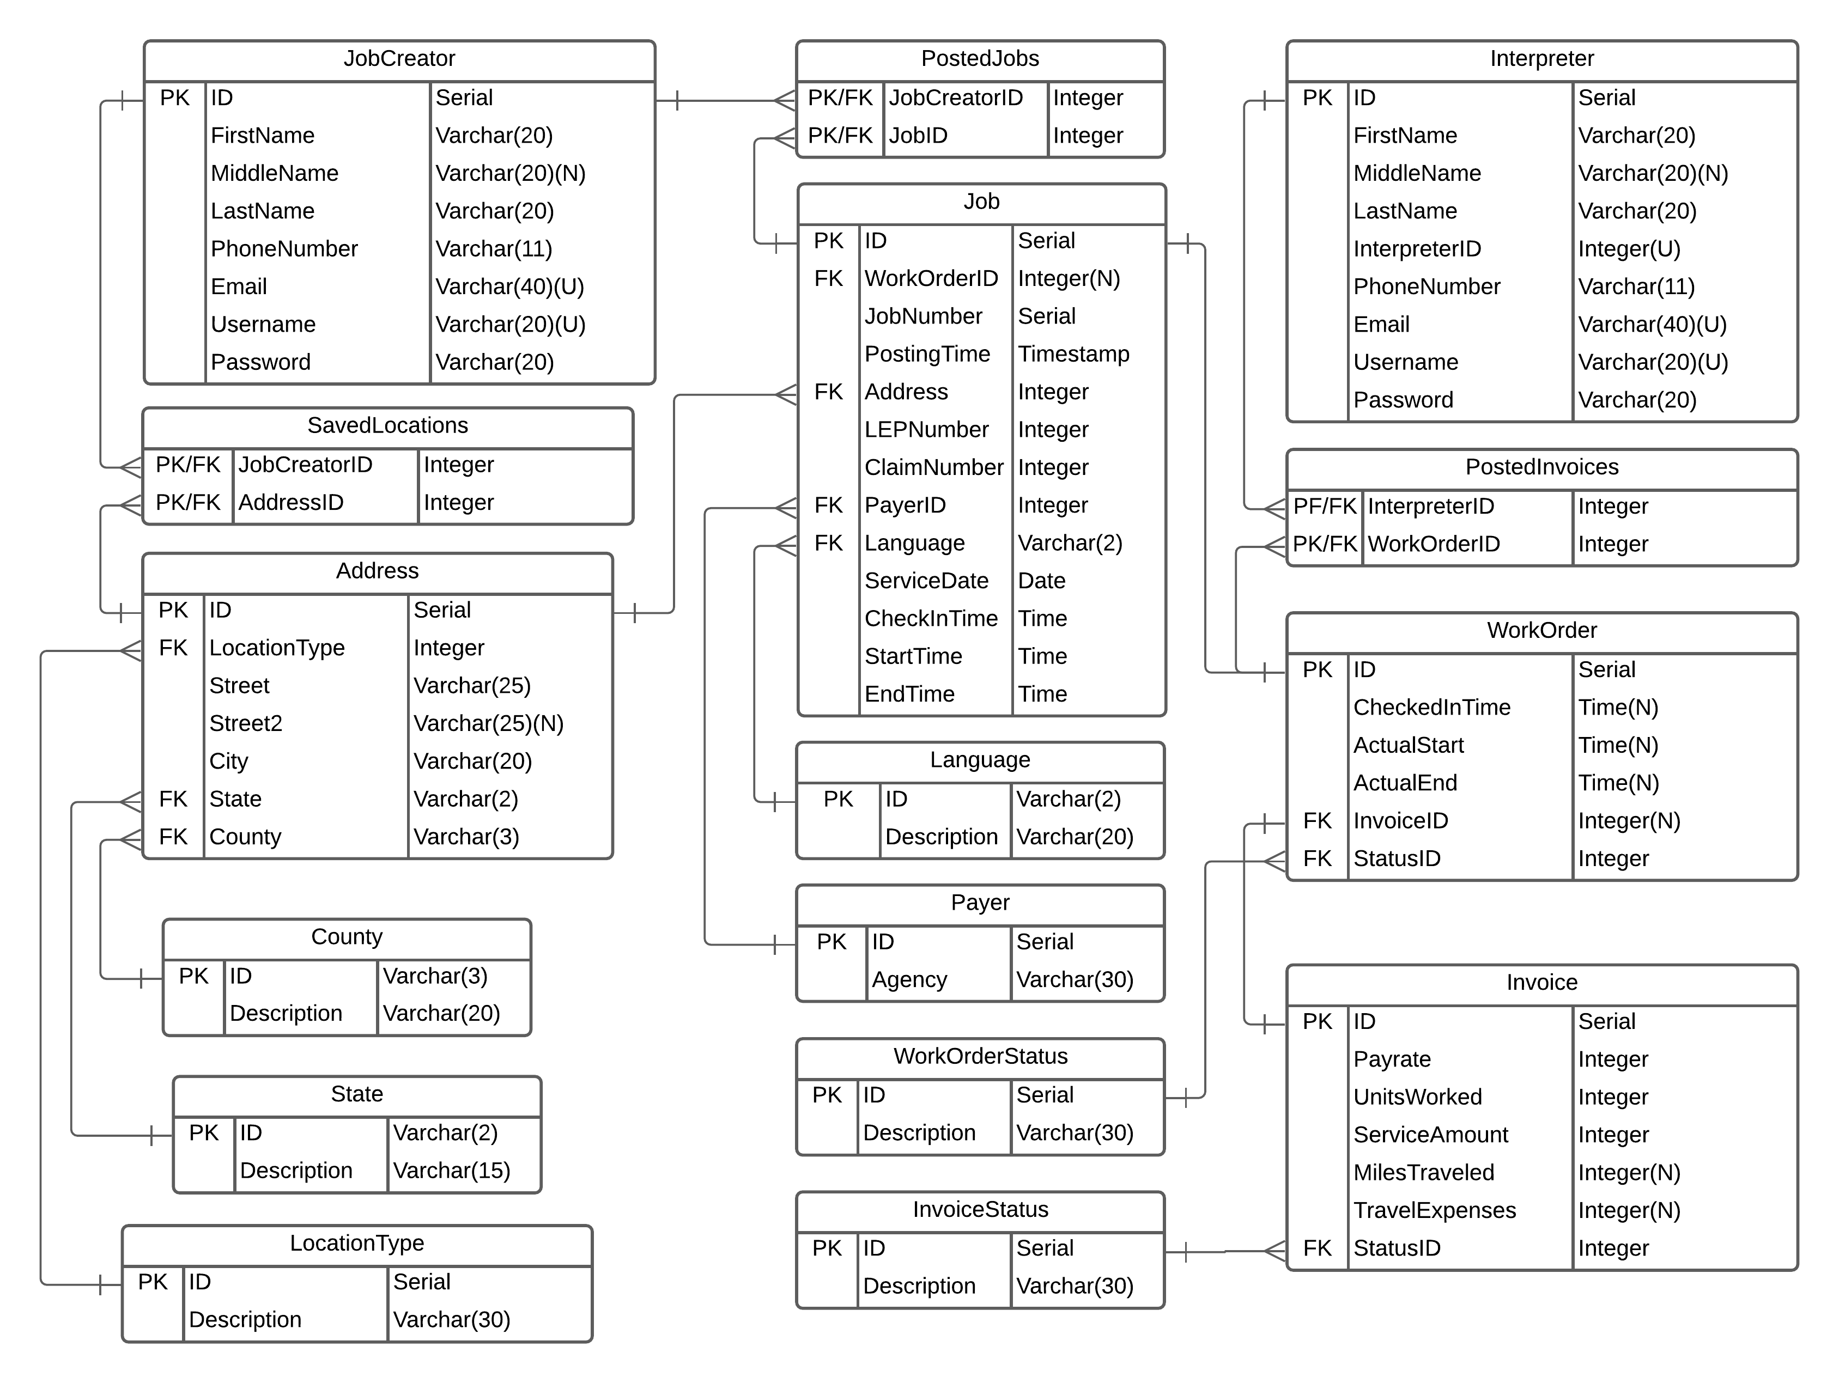

**Explanation**

This table holds all the information for a Job Creator’s account.

|  |  |
| --- | --- |
| **JobCreator** | |
| ID | Internal ID for keeping track of items. |
| FirstName | First name of Job Creator. |
| MiddleName | Optional middle name of Job Creator. |
| LastName | Last name of Job Creator. |
| PhoneNumber | Phone number of Job Creator. |
| Email | Email of Job Creator. Must be unique as it functions as a candidate key. Used to login. |
| Username | Username associated with Job Creator account. Must be unique as it functions as a candidate key. Used to login |
| Password | Password for Job Creator account. Has certain restrictions placed upon what can be here enforced by Python code. |

This table hold address and location information.

|  |  |
| --- | --- |
| **Address** | |
| ID | Internal ID for keeping track of items. |
| LocationType | Location code to specify the locations function. |
| Street | Street address. |
| Street2 | Optional line two for street address if needed for apt or building number. |
| City | City name. |
| State | State code. |
| County | County code. |

A table of saved locations related to the Job Creators that made them.

|  |  |
| --- | --- |
| **SavedLocations** | |
| JobCreatorID | PK/FK to relate Job Creators. |
| AddressID | PK/FX to relate addresses in system. |

Table that has all two-letter representation of states and the corresponding state name

|  |  |
| --- | --- |
| **State** | |
| ID | Two-character code for state. |
| Description | Full state name. |

Table has all three-letter representation of Washington counties and their corresponding full name.

|  |  |
| --- | --- |
| **County** | |
| ID | Three-character code for county. |
| Description | Full county name. |

Table has a list of all types of a location an address may be. Hospital, courthouse, personal residence, etc.

|  |  |
| --- | --- |
| **LocationType** | |
| ID | Internal ID for keeping track of items |
| Description | Location name |

Table contains all relevant information for a job posting item.

|  |  |
| --- | --- |
| **Job** | |
| ID | Internal ID for keeping track of items |
| WorkOrderID | Foreign key relating the specific job to the workorder generated when an interpreter has picked up and confirmed that they want the job. |
| JobNumber | Id number shown along with job. Regenerated whenever something in the job is changed. Must be a unique value to function as candidate key. |
| PostingTime | Time and date the job was posted. |
| Address | Foreign key relating to the address table. |
| LEPNumber | [Talk to sponsor for information] |
| ClaimNumber | [Talk to sponsor for information] |
| PayerID | Relates to Payer table. Value to specify what Government Agency is paying for interpreting services. |
| Language | Language that will be used during interpreter appointment. |
| ServiceDate | Date of appointment. |
| CheckInTime | Time for interpreter to arrive at location. |
| StartTime | Start time of interpreting job. |
| EndTime | End time of interpreting job. |

Table to show which Job Requesters have posted which jobs.

|  |  |
| --- | --- |
| **PostedJobs** | |
| JobCreatorID | PK/FK to relate Job Creators. |
| JobID | Pk/FK to relate Job. |

The table has a list of all languages to select from that currently have interpreters.

|  |  |
| --- | --- |
| **Language** | |
| ID | Internal ID for keeping track of items. |
| Description | Language name. |

Table has a list of all government agencies that may pay for interpreting services.

|  |  |
| --- | --- |
| **Payer** | |
| ID | Internal ID for keeping track of items. |
| Description | Government Agency to pay for job. |

**Proposed Modifications**

* Job Priority Levels
  + Need a way to classify what jobs are more urgent then others. Either create an algorithm that will decide the need based on the type of appointment and the time until the appointment, or let a user mark a priority level.
* Zip code
  + Zip code must be added to address table
* JobNumber
  + Must be changed to unique to meet requirements. In Job table.
* Type of Interpreting Job
  + Need a way for the type of interpreting actions to be specified. Is this document translation? Live interpretation? Other kinds? New entry on Job and a new table needs to be created.
* Comments
  + Need a way to add comments to a specific job. Either by adding a field to create comments, or a new table that joins and stores comments.
* Job name
  + Add a way to quickly search for a job based on the name. Possibly add to Job.
* WorkOrder Table
  + Add association for work orders to JobCreator so a list can easily be seen. Also associate the WorkOrder entry to a Job so it all remains together.